PROJECT DOCUMENTATION

- Title :- Titanic Data Analysis using Python .
Submitted By :- Sujal Sudhakar Salvi .

Course :- Data Analytics .

Submitted To :- Prajakta Tayde .

- Introduction :-
The Titanic dataset is a well-known dataset used to understand data analysis and basic data preprocessing techniques. This dataset contains information about passengers who were traveling on the Titanic ship. The main purpose of this project is to analyze the data and understand survival patterns using simple Python operations. This project helps in learning how to clean data, create new features, and visualize important information.

- Objectives of Project :-
- To load and understand the Titanic dataset
- To handle missing values in the data
- To create simple and meaningful new features
- To visualize survival information using a basic graph
- To prepare clean data for further analysis

- Dataset Description :-
The dataset contains passenger details such as age, gender, ticket information, family details, and survival status. Each row represents one passenger, and each column represents a specific type of information related to that passenger.

- Column Description :-

- PassengerId :- This column contains a unique identification number assigned to each passenger. It is mainly used to identify passengers and does not have any impact on survival analysis.

- Survived :- This column indicates whether the passenger survived the Titanic accident or not.
- Value 1 means the passenger survived .
- Value 0 means the passenger did not survive.
This is the most important column in the dataset as it represents the final outcome.
- Pclass :- This column represents the passenger class in which the passenger was traveling.
- 1 = First Class .
- 2 = Second Class .
- 3 = Third Class .
Passenger class often reflects the social and economic status of the passenger.
- Name :- This column contains the full name of the passenger. It is useful for identification but does not directly help in survival analysis, so it is removed during preprocessing.

- Sex :- This column shows the gender of the passenger, either male or female. Gender plays an important role in survival, as women were given priority during rescue operations.

- Age :- This column represents the age of the passenger in years. Some values are missing in this column, which are handled during data preprocessing. Age helps in understanding survival patterns across different age groups.

- SibSp :- This column shows the number of siblings or spouses the passenger had on board the Titanic. A higher value indicates that the passenger was traveling with family members.

- Parch :- This column represents the number of parents or children traveling with the passenger. Together with SibSp, it helps in calculating the family size.

- Ticket :- This column contains the ticket number of the passenger. It is mainly an identification detail and does not directly help in survival prediction, so it is removed during data cleaning.

- Fare :- This column shows the amount of money paid by the passenger for the ticket. The fare amount often reflects the passenger class and economic status.

- Cabin :- This column contains the cabin number assigned to the passenger. Many values are missing in this column, so it is not directly used in analysis and is removed during preprocessing.

- Embarked :- This column shows the port from which the passenger boarded the Titanic.
- S = Southampton .
- C = Cherbourg .
- Q = Queenstown .
Missing values in this column are filled during preprocessing.
- FamilySize :- This column is created during feature engineering. It represents the total number of family members traveling together, including the passenger. It helps in understanding whether traveling with family affected survival.

- IsAlone :- This column is also created during feature engineering. It indicates whether a passenger was traveling alone or not.
- Value 1 means the passenger was alone .
- Value 0 means the passenger was traveling with family .

- Dataset Analysis :-
- Handling Missing Values in Age Column :-

Explanation :- In this step, missing values in the Age column are handled. Some passengers do not have their age recorded in the dataset, which can cause problems during analysis. To solve this, the missing age values are replaced with the median age of all passengers. The median is used because it gives a balanced value and is not affected by very high or very low ages. This helps in keeping the data complete and ready for further analysis.

- Handling Missing Values in Embarked Column :-

Explanation :- In this step, missing values in the Embarked column are handled. The Embarked column shows the port from which passengers boarded the Titanic. Since this is a categorical column, the missing values are filled using the most common value, also known as the mode. This ensures that the missing entries are replaced with a realistic and commonly occurring port, making the dataset complete and consistent for further analysis.

- Preparing Survival Count for Visualization :-
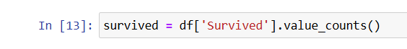
Explanation :- In this step, the Survived column is used to count how many passengers survived and how many did not survive. The value _counts () function calculates the total number of passengers in each category. This summarized data is later used to create a bar graph that visually compares survival and non-survival counts.

- Age Distribution of Passengers (Histogram) :-
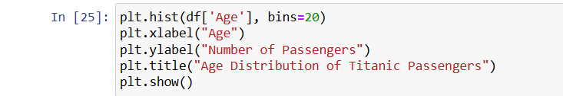
Explanation :- This graph represents the age distribution of passengers on the Titanic using a histogram. The x-axis shows different age groups, while the y-axis shows the number of passengers in each group. Before plotting this graph, missing age values were handled to ensure accurate visualization. This graph helps in understanding the overall age pattern of passengers and provides insight into which age groups were more common on the ship.

- Bar Chart Showing Survival Count of Passengers :-
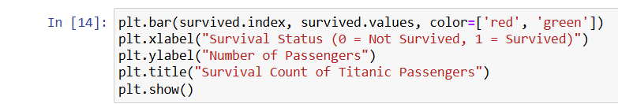
Explanation :- In this step, a bar chart is created to visually represent the number of passengers who survived and those who did not survive the Titanic disaster. The x-axis shows the survival status, where 0 represents passengers who did not survive and 1 represents passengers who survived. The y-axis shows the total number of passengers in each category. Different colors are used for the bars to make the graph more attractive and easy to understand. This graph helps in quickly comparing survival and non-survival counts.

- Creating Family Size Feature :-
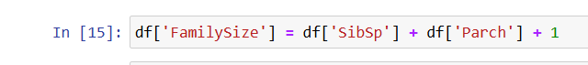

Explanation :- In this step, a new column named FamilySize is created to represent the total number of family members traveling together with each passenger. This value is calculated by adding the number of siblings or spouses (SibSp) and the number of parents or children (Parch), and then adding one to include the passenger themselves. This feature helps in understanding whether passengers were traveling alone or with their family, which can have an effect on survival.

- Identifying Passengers Traveling Alone :-
Explanation :- In this step, a new column called IsAlone is created to identify whether a passenger was traveling alone or not. If the value of FamilySize is equal to one, it means the passenger was traveling alone, so the value is set to 1. If the family size is greater than one, it means the passenger was traveling with family members, so the value is set to 0. This feature helps in analyzing the impact of traveling alone on passenger survival.

- Removing Unnecessary Columns from the Dataset :-
Explanation :- In this step, some columns that are not useful for analysis are removed from the dataset. The Name, Ticket, and Cabin columns mainly contain identification or text information and do not directly help in understanding passenger survival. Also, the Cabin column has many missing values. Removing these columns helps in simplifying the dataset and makes it easier to work with relevant features during further analysis.

- Encoding Categorical Columns Using One-Hot Encoding :-
Explanation :- In this step, categorical variables in the dataset are transformed into numerical format using one-hot encoding. The columns Sex and Embarked contain text values such as male/female and boarding ports, which cannot be directly processed by machine learning algorithms or numerical analysis methods. To solve this, the get_dummies() function is used to create new binary columns for each category, where a value of 1 represents the presence of that category and 0 represents its absence. The drop_first parameter is applied to remove one category from each column in order to prevent duplicate information and reduce multicollinearity. After applying one-hot encoding, the dataset contains only numerical values, making it suitable for further analysis or predictive modeling.

- Conclusion :-
In this project, the Titanic dataset was analyzed using Python libraries such as Pandas, NumPy, and Matplotlib. The data was first cleaned by handling missing values in important columns like Age and Embarked. Unnecessary columns were removed to make the dataset simpler and easier to understand. Feature engineering was performed by creating new columns such as FamilySize and IsAlone to gain better insights into passenger behavior. A bar chart was used to visualize the survival count of passengers, which helped in understanding the difference between survived and non-survived passengers. Overall, this preprocessing and analysis helped in preparing the dataset for further analysis or machine learning models. This project improved understanding of data cleaning, feature engineering, and basic data visualization techniques.

